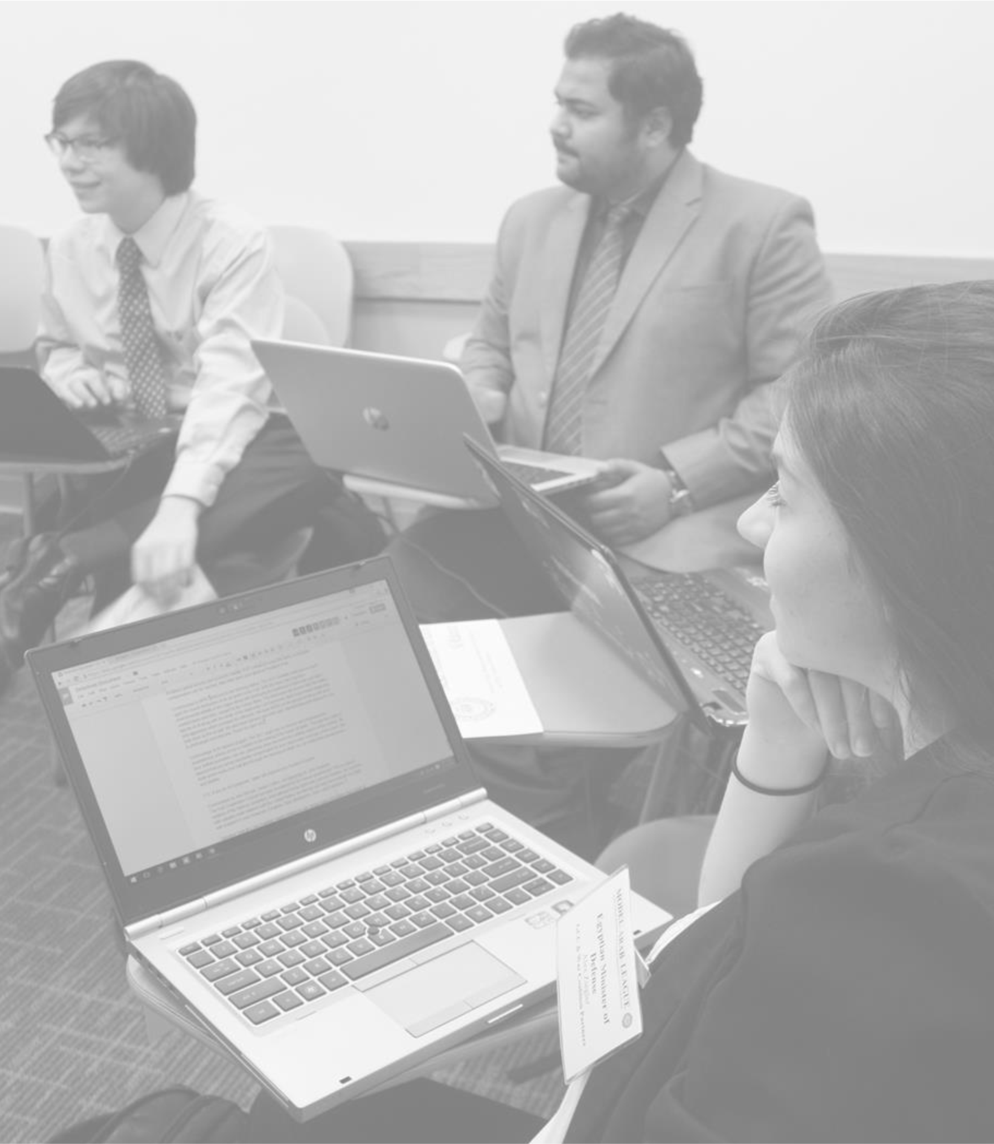

CRISIS HANDBOOK



TABLE OF CONTENTS

Introduction to Model Arab League 3

The National Council on U.S.-Arab Relations 3

A Brief Background of the Model Arab League Program 3

What is Crisis? 4

The Players 5

Rules of the Game 6

It’s the end of the world as we know it? 8

# INTRODUCTION TO MODEL ARAB LEAGUE

## THE NATIONAL COUNCIL ON U.S.-ARAB RELATIONS

Founded in 1983, the National Council on U.S.-Arab Relations (NCUSAR) is a non-profit, nongovernmental, educational organization based in Washington, D.C. dedicated to improving knowledge and understanding of the Arab world. The National Council works to improve U.S.Arab relations through people-to-people and leader-to-leader exchanges along with a wide variety of educational programs in the United States. For details on the National Council’s full range of student opportunities – internships, study abroad, and exclusive travel opportunities – please visit [www.ncusar.org.](http://www.ncusar.org/)

The National Council understands that positive changes in the U.S.-Arab relationship require exposure, interaction, and conversation at a personal level. The National Council works to provide opportunities that have been proven to enrich student leadership and career skills, as well as academic offerings related to international affairs and the study of the Arab world. The largest such program is the Model Arab League.

## A BRIEF BACKGROUND OF THE MODEL ARAB LEAGUE PROGRAM

Since 1983, the Model Arab League Program (MAL) has offered American students an extraordinary opportunity to learn, practice, and develop essential leadership skills. Through MAL participation, students deepen their knowledge and understanding of the most critical social, economic, cultural, and political issues in the Arab world today. Students must work together to address problems and achieve consensus on questions with which diplomats wrestle on a daily basis. The dynamic and interactive nature of the program’s emphasis on role-playing stimulates creativity, enhances learning, and cultivates understanding as no book, lecture, or coursework ever could.

Participation in a Model holds value for all students, regardless of their academic major or the subject matter of their courses. Participants gain valuable leadership training through the Model’s constant challenges in debating, writing, editing, public speaking, critical thinking, and interpersonal relations. All delegates come away having practiced the kinds of skills that will serve them well throughout their academic years, future careers, and personal lives. Year after year, delegates return to participate over and over until they graduate.

The first Model Arab League began at Georgetown University in Washington, DC in 1981. An idea conceived by Dr. Michael Nwanze, the MAL was based on the same general structure as the Model United Nations, a similar student debate program that had existed for several decades. Under the guidance of Dr. John Duke Anthony, the National Council was the first sponsor of the program and has coordinated, organized, and funded the Models since 1983.

Regional models began to form as word of the Models spread to university faculty across the United States. In 1991, the first high school Model Arab League was established in Atlanta, Georgia. By the 2014-15 academic year, there were nearly 20 models at both the university and high school levels, with national conferences for both high schools and universities. Many international MAL conferences have been founded as the program has been replicated the world over. Upwards of 150 universities, colleges, and high schools now participate, with over 2,000 total participants annually. The National Council oversees the coordination of all the Models and acts as the primary sponsor.

# WHAT IS CRISIS?

The crisis committee is a special committee which simulate responses to crises with additional events that can unfold in real time. Decisions made in committee will have consequences on how the events of the crisis unfold. A crisis committee does not engage in formalized debate as often as regular committees, though at times the chair may use his/her discretion to recommend formal debate.

At Model Arab League conferences, crisis committees take the form of a government cabinet or group of leaders who have specific functions which affect their policy recommendations. One example is the formation of the UAE, in which delegates from each of the emirates came together to negotiate the unification of the Trucial States following the British withdrawal from the region.

Similar to other MAL Councils, the Chair acts as a mediator of formalized debate between delegates. Though crisis committees are less formalized, debate will often flow through the same means as other MAL councils at the discretion of the chair. Unlike other MAL councils, however, delegates may use directives and communications to influence the events of the crisis. These communications are routed to the backroom who can implement them into the story, or deny them. (See *Crisis Committee Guidelines*).

Overall, crisis committees represent a type of debate which is more responsive, relying on information about the crisis to make its decisions. It is more interactive, involving collaboration between different types of leaders, from heads of state/government to business representatives, which provides a unique learning experience. In past simulations there have been assassinations, invasions, and even the creation of a new Kurdish national anthem. These events are typical of a crisis committee because they combine real-world consequences with the unknown. Most often, information flows quickly, but in some cases, the motivations and the consequences within the crisis simulation occur in real-time, as do the responses. The crisis committee tries to simulate the complex nature of political interactions. It's also a ton of fun!

# 

# THE PLAYERS

## There are three main types of members who participate in a Crisis Committee: The Crisis Coordinator, the Chair, and the Delegates.

## THE CRISIS COORDINATOR(S):



The Crisis Coordinator represents the Home Government, other governments, the news, and more. Any role that is not portrayed by other delegates is played by the coordinator(s). Sometimes this may take the form of messages from Home Government detailing information on a crisis. Other times this may take the form of external governments and experts who are called upon to provide context or assistance for the crisis. At other times this may take the form of press releases containing more information or media personal who publish interviews. The Coordinator is responsible for all of the information of the Crisis Committees. Information and actions must pass through the Coordinator before it goes anywhere else. Directives or proposed projects must also be sent to the Coordinator for approval/denial/results. The Coordinator also sends out new information regarding the crisis, global events, and other relevant happenings. The Crisis Coordinator additionally has the power to cause events to happen which are not requested by any delegate throughout the simulation, including events which are antagonistic or beneficial to the committee. The Crisis Coordinator has the capacity to impact the crisis at any point for the purpose of challenging the committee.

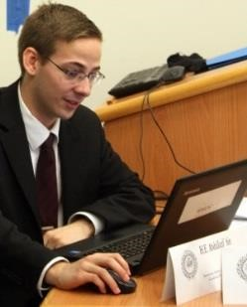

## CHAIR:

The Chair is responsible for ensuring that the Cabinet is well-run. Some of their duties include managing debate, encouraging shy speakers, and promoting a realistic approach to the crisis. Sometimes debate can become hectic, chaotic, and silly. Part of the Chair’s job is to keep delegates focused on the real-world response.

## DELEGATES:

Individual delegates represent various characters. Their job is to portray their characters, with all of their particular motivations. This means understanding that person’s background, interactions with other government officials, and any other possible motivating factors. An accurate representation of the person is important because it will help facilitate the overall debate and response to the crisis. Delegates can also win individual awards for their performances within the crisis committee at MAL conferences.

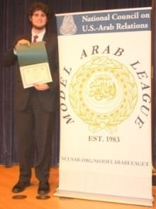

# Crisis Committee Guidelines

The crisis committee is interesting in that it is not bound by the laws of time, and can sometimes be structured in a manner that suspends certain elements of parliamentary procedure. Essentially, the crisis becomes an alternate universe in which crises are occurring and events deviate from those of the real world. The goal is to create a simulation where the room responds to the crisis as their corresponding real-world governments would.

**TIME**

The rules of time are different in the crisis committee. The timeline can be sped up or slowed down as needed. Occasionally, some crises will have an escalated timeline. In other instances, the Coordinator may need to slow things down if too many requests are coming in and they are not able to respond to all of them in a timely manner. If one of these situations occurs, the Coordinator will inform you.

**COMMUNICATION**

Communication is the key to Crisis. All communication must go through the Coordinator. This includes communication to: external government actors, governments not represented in the room, nongovernmental actors, and external corporations (This does not, however, include other delegates in the room, to whom delegates are free to pass notes). Delegates may also request a briefing from an outside organization, but this too must go through the Coordinator. This is to ensure that the Coordinator knows what is going on within the committee at all times. This knowledge allows them to anticipate the needs of the committee and to prepare new information. It is also important to note that nothing can happen until the Coordinator responds to your communication or directive. This means that anything your committee wishes to put into action must be approved or denied by the Coordinator.

**ACTIONS**

There are several actions available to the delegates, including: directives, communiques, and press releases.

## DIRECTIVES, MESSAGES SENT TO "HOME GOVERNMENT"

Directives to “Home Government” are messages sent to the Coordinator on behalf of the crisis committee. These directives are sent via email and are meant to be requests for policy actions to be carried out and occur within the simulation.

*Exampl*e: From: Egypt

To: Coordinator

Message: Egypt is sending air force patrols over Libya.

From: Jordan

To: Coordinator

Message: Jordan is opening more refugee camps for displaced Syrians.

Directives may become publicized through leaks to the press by the Coordinator in order to move the crises along; additionally, things might “go wrong” (Egypt's air force strikes a civilian target, Jordan's camps become infiltrated by militants, etc). Nothing is ever certain to happen, however, the Coordinator uses diligent judgement to keep the crisis moving and on target. These requests may also be denied by the Coordinator if too extreme or not pertinent to the course of the crisis.

## COMMUNIQUES

Communiques are meant to be sent to a specific government(s), however all communiques must pass through Home Government (Coordinator).

Example: To: Coordinator

From: Syria (Assad Regime)

Message: Communique to Russia “We request military aid on the behalf of our people and our government.”

Communiques could be intercepted, published, leaked, or altered, just as with directives. They can also be denied by the Coordinator.

## PRESS RELEASES

Press Releases are meant to be published to the media for all governments and Cabinets to see; however, they must still be sent to the Coordinator/Home Government before being published. Press releases may be published and altered. They may also be denied by the Coordinator.

There are additional options available than those listed above, such as asking the Coordinator to pass along messages to specific people not represented in the room, requesting more information, requesting meetings between representatives, and asking the Coordinator to send a representative to brief the Committee – this representative could be from an international organization or other related party. In crisis, the sky’s the limit in terms of requests. If you can think it, ask your Coordinator.

**CHANCE**

As stated above, all actions and communications within crisis must be directed to, approved by, or denied by the Coordinator. If your actions seem reasonable, then they are usually approved. However, approval does not mean that the actions will go the way you thought they would. For example, let’s say Country A opens its borders to Country B after a crisis in Country B has created a large number of refugees. Country A’s decision will help these refugees, but it also offers up the opportunity for another crisis. Militants within refugee populations could enter Country A, disease could break out in backed-up border crossings, etc. Each action should be weighed carefully before requests are made to the Coordinator. This factor, which we like to call the “chance factor,” can also affect the approval/denial of your requests. If your committee derails and begins to make requests which do not seem likely, then the Coordinator will consider if the action is possible, probable, and/or wise.

The Coordinator additionally has the power to cause events to happen which are not requested by the characters throughout the simulation, including events which are antagonistic or beneficial to one or more goals. The Coordinator has the capacity to impact the crisis at any point for the purpose of challenging the Committee.

# IT’S THE END OF THE WORLD AS WE KNOW IT?

At the end of the conference, the Crisis’s success or failure is determined by whether or not the Committee solved the initial crisis, how well each individual delegate was able to achieve their individual goals, and if the world is still standing.

The Crisis engages in realistic simulated crises. The thoughts and actions taken by the Committee should reflect a real-world crisis response. These issues are serious, with potentially devastating consequences. Though the crisis can be a lot of fun, it is our hope that the crisis provides a more realistic simulation of governments under crisis. There are many pressures facing governments even without the additional demands of a crisis. Delegates need to understand not only their individual role’s and their assigned committee member’s policies, but also that of their neighbors, allies, and enemies. The stage of global politics is increasingly complex. Understanding the moves and countermoves involved is not only a good foundation for furthering your study of political theory but also a practical lesson in applying political decisions.

As always delegates, may the odds be ever in your favor.