**PROPOSAL #1 – RAILROAD/ROAD TO BYPASS STRAIT OF HORMUZ**

**Background**: Strait is in the territorial waters of Iran and Oman, which at its narrowest point is just 21 miles wide. The width of the shipping lane in either direction is only 2 miles.

Anything affecting it ripples through global energy markets, potentially raising the price of crude oil. This means higher prices for consumers for gasoline and other oil products.

About 30 percent of the world’s oil supply (21 million barrels per day) passes through the Strait.

About one-fifth of the world’s LNG trade passes through the Strait.

Grain to desert nations, containers of everything from fruit to toys, and ores and minerals also pass through the Strait.

2018: Trump admin pulls out of Iran nuclear deal after repeated Iranian violations and reimposes economic sanctions.

April 2019: *USS Abraham Lincoln* (aircraft carrier) deployed to the region.

2021: Biden admin lifts sanctions and facilitates billions in payments to Iran.

Iran has “harassed, attacked or interfered” with 15 internationally flagged merchant ships since 2021, Pentagon and White House officials said this month, as they announced the move to increase patrols by U.S. Navy ships, drones and planes, as well as those of United States allies in the region.

Seizures increased in 2023, leading a major maritime insurer to advise staying away from Iran as much as possible to avoid attacks.

May 2023: Panama-flagged oil tanker Niovi seized by IRGC in Gulf.

Very few attacks are necessary to have a devastating effect on world commodity prices. Cost of insurance alone will force higher prices and disrupt supplies.

August 2023: U.S. military announces plans to deploy armed troops to ships in the Strait. Major deployment in the region, including thousands of Marines and sailors on both the amphibious assault ship *USS Bataan* and the *USS Carter Hall*, a landing ship.

**Existing and Proposed Bypasses**: Dubai canal plan 2008; Al Ain Road in UAE (106 miles, 2 hrs);

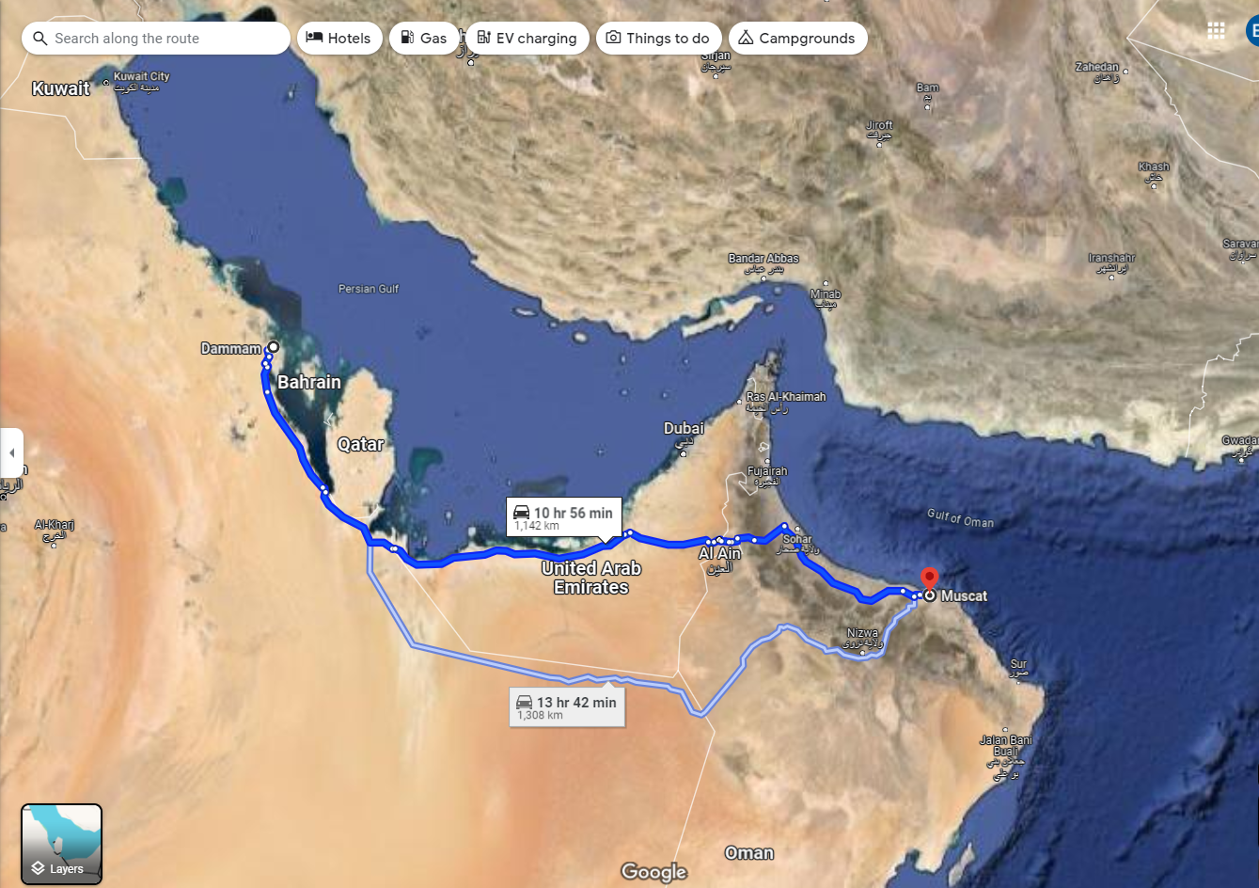

Tolls

**Proposal:** *1142 km (708 m) from Dammam, KSA to Muscat, Oman. Seed money (amount$$$) for a railway company to construct a new line running from Dammam to Muscat. Sponsored by KSA. Prior negotiations with oil, LNG, and other large regional productions to determine additional funding, likelihood of use, etc.*

**Difference between a canal and a road-railway bypass:** Goods other than those that can be piped or shipped;

**Questions to be Answered by the Board of Executive Directors:**

**Advantages:**

**Consistency with Sharia lending:**

**Winners and losers:**

**Estimated costs:**

**Budget:**

**Oversight system:**

**Questions to consider as you decide upon funding:**

* Why not improve the existing roadway(s) instead of constructing a new bypass?
* Would it be better to construct from Dammam to Salalah?
* How does this relate to tourism?
* Rail or road?
* Why not a pipeline to limit/eliminate oil shipping through the Strait?

Useful Links:

<https://www.isdb.org/>

<https://www.isdb.org/who-we-are/about-isdb>

<https://www.isdb.org/what-we-do/sectors>

<https://www.freightwaves.com/news/dubai-considering-canal-to-bypass-strait-of-hormuz>

<https://www.nytimes.com/2023/05/23/us/politics/us-navy-iran-ship-seizures-strait-of-hormuz.html#:~:text=Iran%20has%20%E2%80%9Charassed%2C%20attacked%20or%20interfered%E2%80%9D%20with%2015,those%20of%20United%20States%20allies%20in%20the%20region>.

<https://apnews.com/article/persian-gulf-tensions-hormuz-iran-us-shipping-6d33ae164cb5f89a0347634b2ed45ae7>

<https://apnews.com/article/iran-us-oil-tanker-seizure-strait-of-hormuz-e838ea969907ee39a8c7f949a96aa777>

<https://oxfordbusinessgroup.com/reports/saudi-arabia/2020-report/transport/full-throttle-moving-ahead-with-local-and-regional-rail-network-integration-analysis/>

<https://www.arabnews.com/uae-starts-pipeline-bypass-strait-hormuz-1>