Resolution Format Checklist
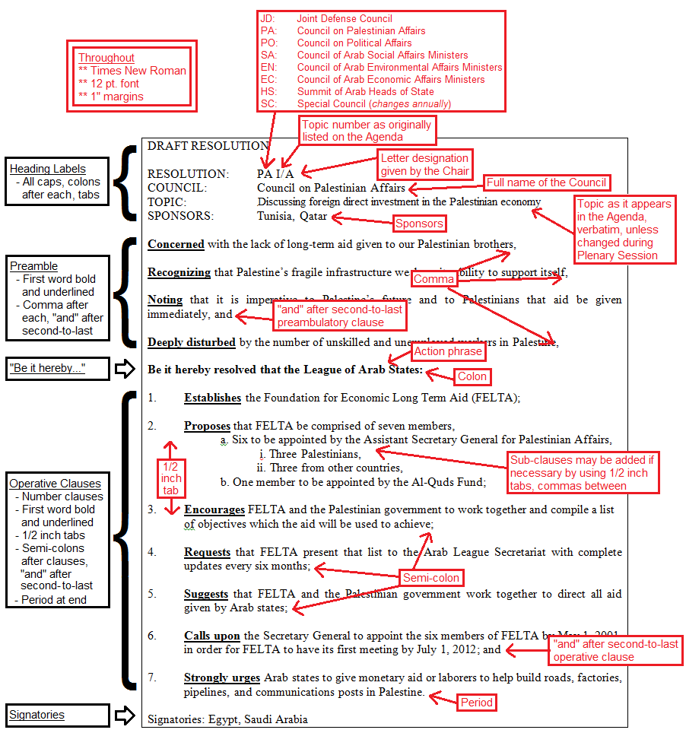

General
  - Font: Times New Roman
  - Size: 12
  - Margins: 1 inch

Headings
  - DRAFT RESOLUTION – typed in top left corner, all caps, empty line below
  - RESOLUTION: – all caps with colon, tab to [Council Abrev. Topic/Chair’s designation]
  - COUNCIL: – all caps with colon, tab to [Full Name of Council]
  - TOPIC: – all caps with colon, tab to [Full Language of Topic being Addressed]
  - SPONSORS: – all caps with colon, tab to [List all Sponsors]

Preamble
  - First word of each clause Bold and Underlined
  - Comma at end of each clause
  - No line spacing within clauses; empty line between separate clauses
  - , and after the second-to-last clause

Operative Clauses
  - Be it hereby resolved that the League of Arab States: – bold, colon following
  - Each line numbered, ½ inch tab between number and clause
  - First word of each clause Bold and Underlined
  - Semi-colon at end of each clause
  - No line spacing within clauses; empty line between separate clauses
  - Sub-clauses tabbed additional ½ inch, separated by commas, each line lettered
  - Sub-sub-clauses tabbed additional 1 inch, separated by commas, roman numerals used
  - ; and after the second-to-last clause
  - Period after final clause
  - Signatories: – typed in bottom left corner, colon following, list all Signatories
